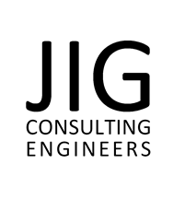

Slavery & Human Trafficking Policy

JIG Consulting Engineers Ltd
Trinity Trees
126 Orrell Road
Wigan
WN5 8HJ

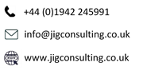

General Statement of Policy

At JIG Consulting Engineers Limited we recognise our duties under the Modern Slavery Act 2015 Section 54(1) and have a zero tolerance approach to Modern Slavery both in our business and that of others whom form part of a supply chain. We will act with integrity and ethically in all our business relationships and to implement and enforce effective controls to ensure that Modern Slavery and Human Trafficking are not taking place anywhere in our business.

Modern Slavery is a crime and a violation of fundamental Human Rights, we fully support the government’s objectives to eradicate modern slavery and human trafficking. The Company will not support or deal with any business knowingly involved in slavery or human trafficking.

The Company Directors shall take responsibility for implementing this policy statement and its objectives and shall provide adequate resources and training to ensure that slavery and human trafficking is not taking place within the organisation. This policy along with all policies, procedures and requirements that are documented in our Business Management System are compliant with the requirements of ISO 9001, ISO 14001 and ISO 45001 and will be reviewed annually by the Directors of JIG Consulting Engineers Limited to maintain its suitability and compliance within the Company.

In the event that JIG Consulting Engineers Limited suspects any slavery and human trafficking by an employee or business collaboration, JIG reserves the right to: report such suspicions, provide appropriate information to the relevant authorities, and to suspend or terminate any associated engagement, business arrangement or contract.
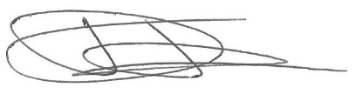
Signed:

David Taberner
Director
Date: 08th January 2026
Review date: 08th January 2027

